BCA List of References
23 U.S. Code § 150 - National goals and performance management measures
American Transportation Research Institute (ATRI), 2021. Analysis of the Operational Costs of Trucking: 2021 Update.
American Automobile Association (AAA), 2022. YOUR DRIVING COSTS How Much Are You Really Paying to Drive? Retrieved from: (https://truckingresearch.org/), May 22, 2022).
FEMA, 2009. BCA Reference Guide. Sub-reference: HAZUS-MH MR3 Flood Technical Manual, Table 14.10.
National Weather Service, 2022. Flood Return Period Calculator. Retrieved from: https://www.weather.gov/epz/wxcalc_floodperiod (May 22, 2022).
Puerto Rico Planning Board, 2019. Municipality of Mayagüez Hazard Mitigation Plan.
U.S. Energy Information Administration, 2022. Annual Gas Savings Value. Retrieved from https://www.eia.gov/.
U.S. Department of Transportation, 2022. Notice of Funding Opportunity for the Department of Transportation’s Multimodal Project Discretionary Grant Opportunity.
U.S. Department of Transportation, 2022. Benefit-Cost Analysis Guidance for Discretionary Grant Programs, March 2022 (Revised).
BCA Tables and calculations: | Resource:
Table A-1: Value of Reduced Fatalities and Injuries | Traffic Impact Study and Access Modification Justification (Pages 70-87)  (Page 83)  Fatality: 4 (1.33 por año)  Injured: 119 (66.33 per year)  These numbers are for 3 years.
Table A-2: Property Damage Only (PDO) Crashes | Traffic Impact Study and Access Modification Justification (Page 83)  423 Property Damage  $4,600 x 423 PD = $1,945,800
Table A-3: Value of Travel Time Savings | Source: DOT Benefit Cost Analysis Guidance for Discretionary Grant Programs of March 2022, Traffic Study AC-200241, PPA Calculations
Table A-4: Average Vehicle Occupancy Rates for Highway Passenger Vehicles | Traffic Impact Study and Access Modification Justification (pages 20-37)
Table A-5: Vehicle Operating Costs | Average Annual Cost for Road Maintenance by Operational Maintenance Level  R9RoadMaintanceAnnualCost.xlsm (usda.gov)
Table A-6: Damage Costs for Emissions per Metric Ton | Categorical Exclusion  Appendix A: (Carbon Monoxide Emissions Screening)  https://panzardi.sharepoint.com/:b:/s/BCAPROJECTS/EVPTl12-Z-FGld5sCErc7BEB6314jx0cTic_HJMskTFOPg?e=gGW3GK
Table A-7: Inflation Adjustment values | U.S. Department of Transportation, 2022. Benefit-Cost Analysis Guidance for Discretionary Grant Programs, March 2022 (Revised).
Table A-8: Pedestrian Facility Improvements Revealed Preference Values | Categorical Exclusion  (Page 13-17) https://panzardi.sharepoint.com/:b:/s/BCAPROJECTS/EVZQl9BUgFtJgjR2RMzwTC0Bj-dMbiMlXqEoE1mwiIW05Q?e=thrDn4  Presentation:  https://panzardi.sharepoint.com/:b:/s/BCAPROJECTS/ERkphZJUUfVGtWhwiHprQZIBGY7sX8xOnJXyTaGfmFhcFg?e=o981Si
Table A-9: Cycling Facility Improvement Revealed Preference Values | Categorical Exclusion  Pages 15-17
Table A-10: Transit Facility Amenity Revealed and Stated Preference Values | Traffic Study, JABA
Table A-11: Transit Vehicle Amenity Values | Traffic Study, JABA  Puerto Rico Highway and Transportation Authority, CMF Clearinghouse
Table A-12: Mortality reduction Benefits of Induced Active Transportation Values | Traffic Study, JABA
Table A-13: External Highway Use Costs: Noise and Congestion Values | Traffic Study, JABA;  Noise Study, JABA
Calculations:
Inflation Adjustment Calculation | See Excel Tables in BCA Report
Discounting Calculation | See Excel Tables in BCA Report
Calculation of Benefits to Existing and Additional Users | See Excel Tables in BCA Report
Value of Time Savings Calculation | See Excel Tables in BCA Report
Crash Modification Factor Calculation | See Excel Tables in BCA Report
Safety Benefits Calculation | See Excel Tables in BCA Report
Emissions Benefits Calculation | See Excel Tables in BCA Report
Pedestrian Journey Quality Valuation Calculation | See Excel Tables in BCA Report
Reduced Crowding Calculation | See Excel Tables in BCA Report
Residual Value Calculation | See Excel Tables in BCA Report
Cycling Journey Quality Valuation Calculation | See Excel Tables in BCA Report
Active Transportation Mortality Reduction Benefit Calculation | See Excel Tables in BCA Report
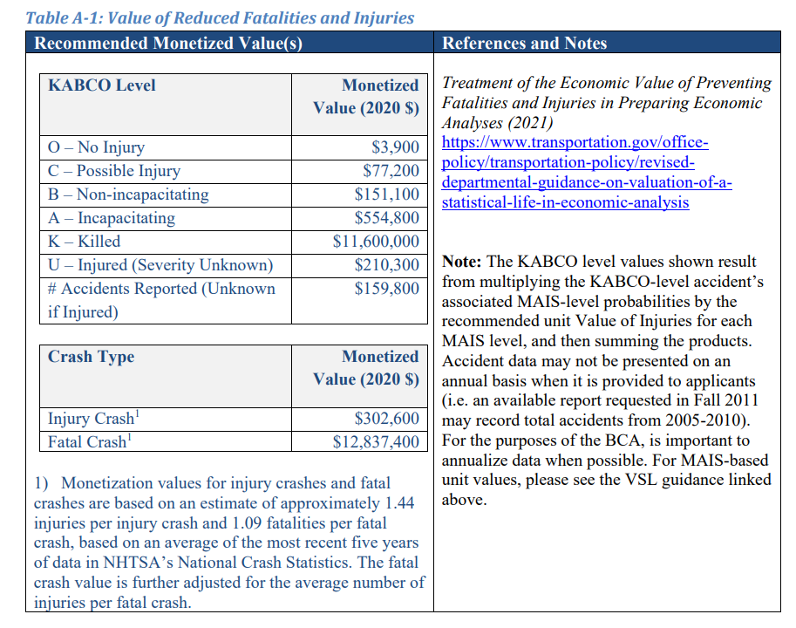
BCA TABLE

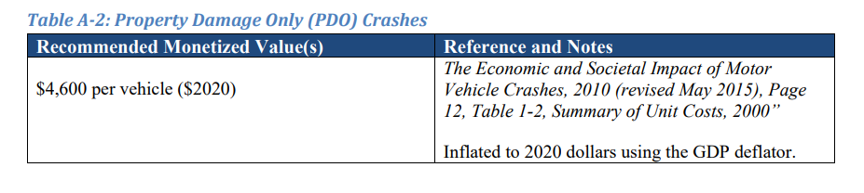

BCA TABLE

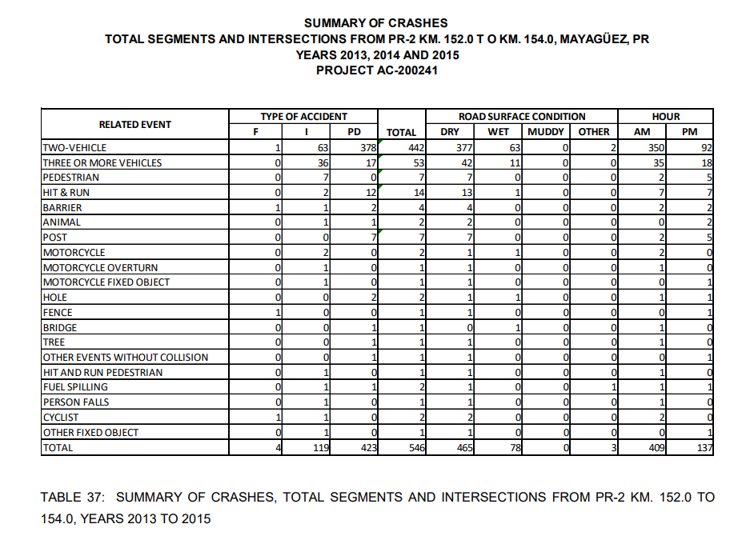
RESOURCE
PAGE 83
Traffic Impact Study and Access Modification Justification

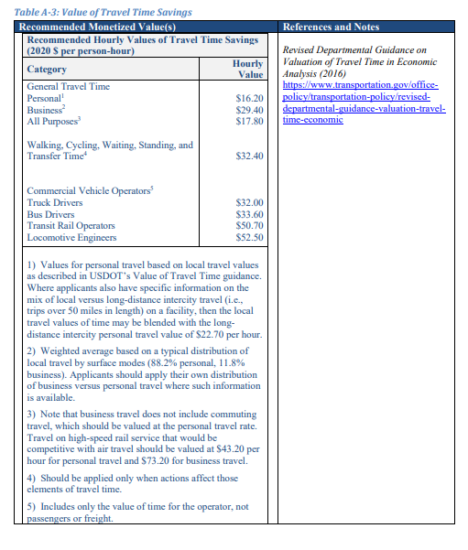
BCA TABLE

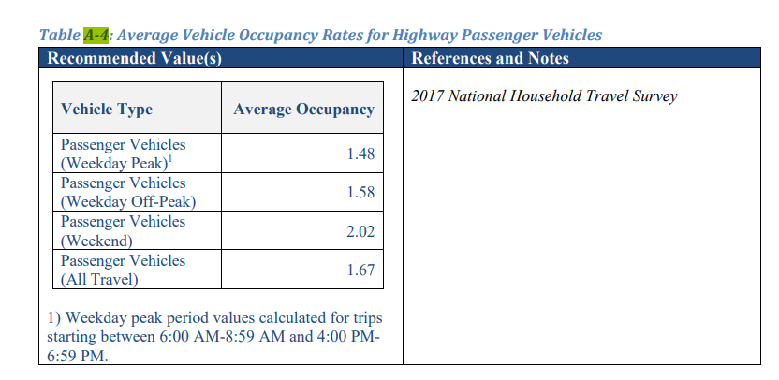
BCA TABLE

